CAPACITY
MEASURE | UNIT | VISUAL | EQUIVALENT
teaspoon | tsp | 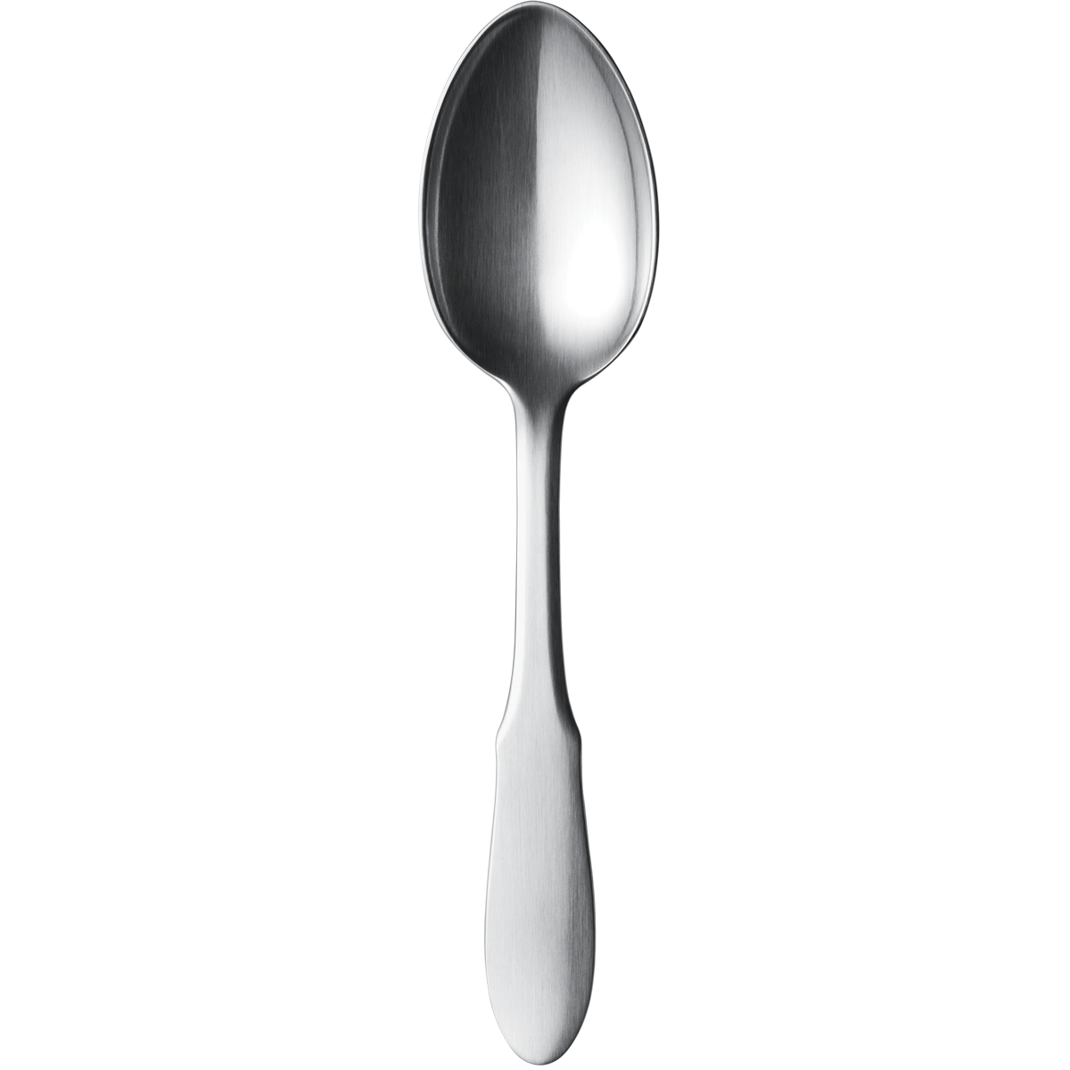
Tablespoon | Tbsp | 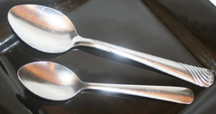 | 3 tsp.
Fluid ounce | Fl. oz | 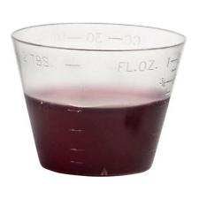
cup | c. | 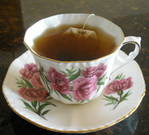 | 8 fl. oz.
pint | Pt. | 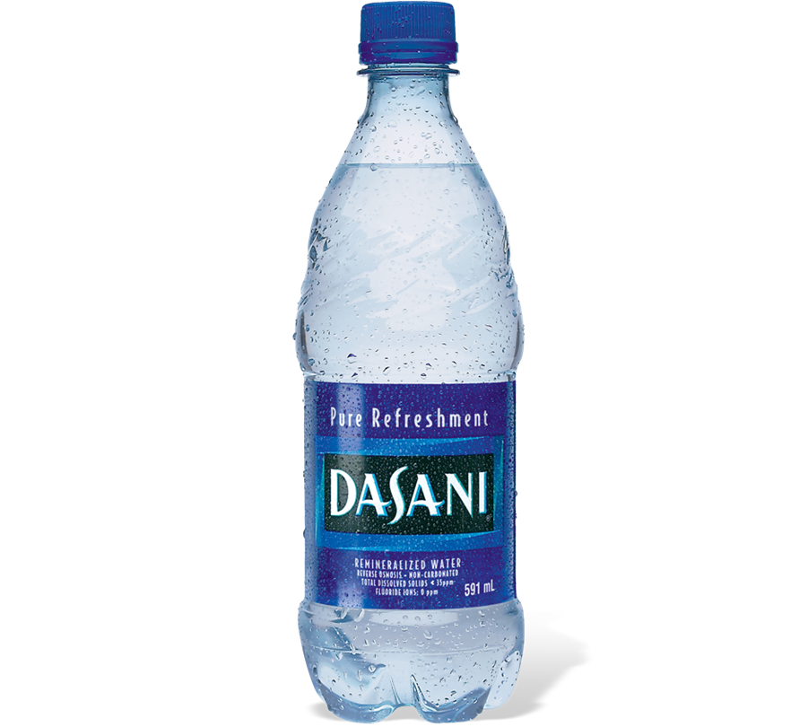 | 2 c.
quart | Qrt. | 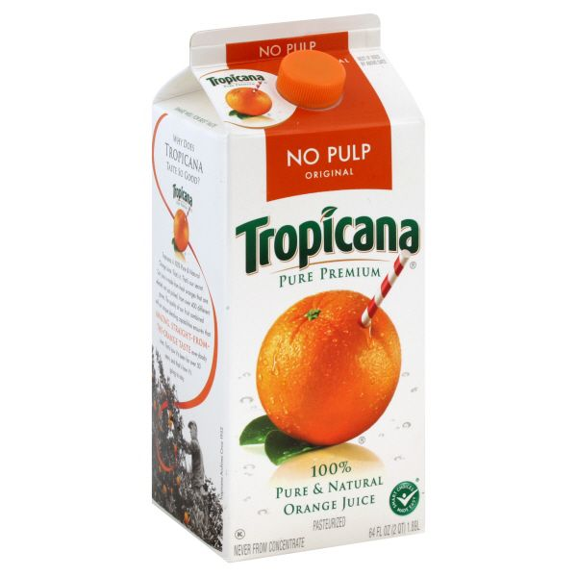 | 2 pt.
gallon | g | 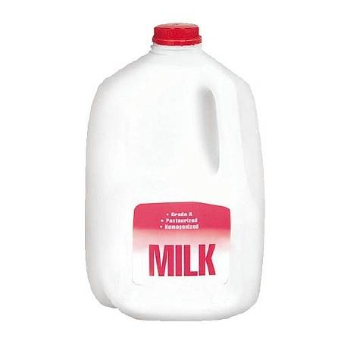 | 4 qrt.
WEIGHT
ounce | oz | 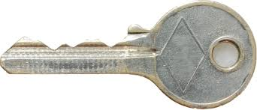
pound | lb | 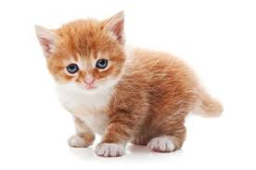 | 16 oz
ton | t | 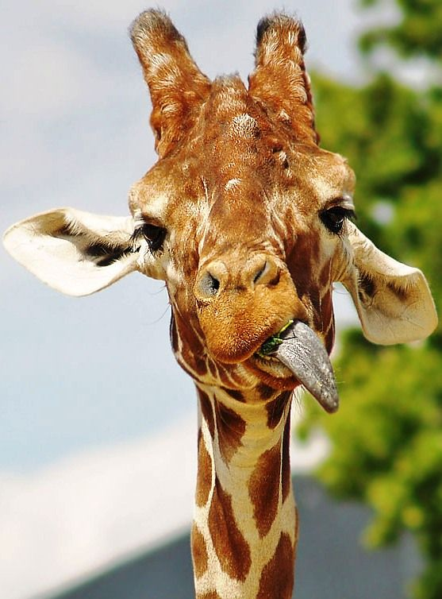 | 2,000 lbs.
Length
inch | in. | 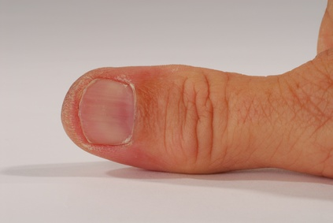
foot | ft. | 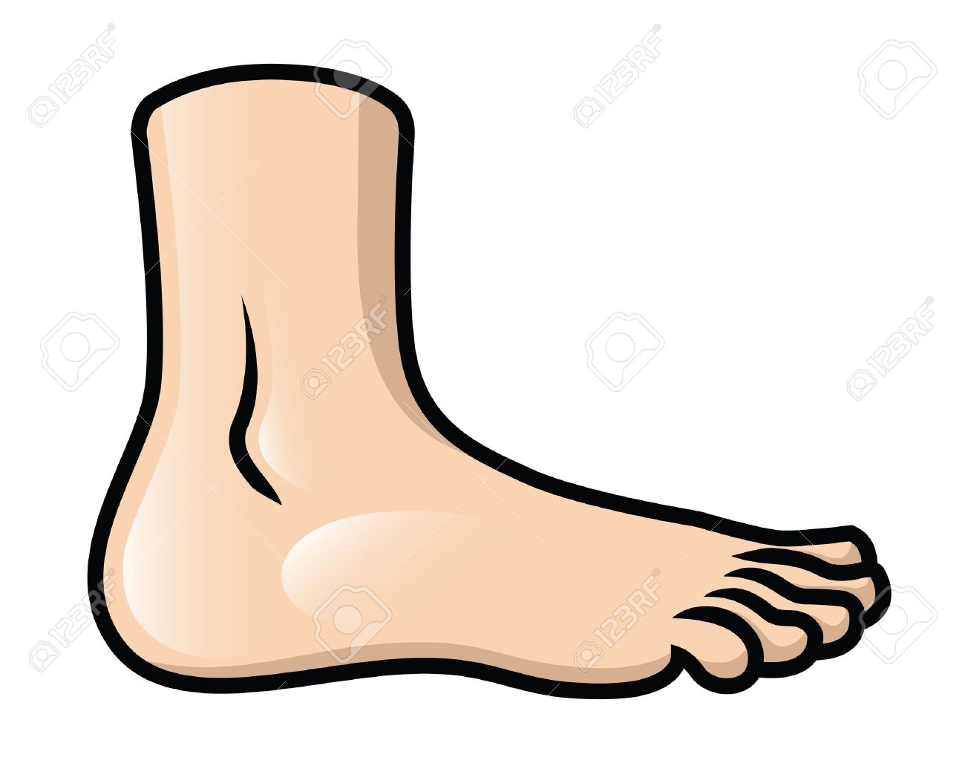 | 12 in.
yard | yrd. | 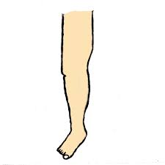 | 36 in.  3 ft.
mile | mi. | From Cambridge to the baseball fields | 1,760 yards

